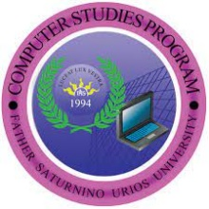

FATHER SATURNINO URIOS UNIVERSITY

Computer Studies Program

Butuan City

July 18, 2023

Butuan City, Agusan Del Norte

Dear Sir/Ma’am,

We, a group of Computer Studies Program course of Bachelor of Science in Information and Technology students at Father Saturnino Urios University, are writing to request your permission for an interview as part of our thesis project. Our research focuses on "**Rambul**: A Mobile Application Enhancing Motorcycle Transportation Services for Efficient Travel in Butuan City".

As one of the respondents. your insights and expertise are highly valuable to our study. The interview will be conducted with utmost confidentiality and respect for any sensitive information.

We anticipate that the interview will take approximately 10 minutes or less and are flexible to conduct it in person, over the phone, or via a video conference call, according to your convenience. Your participation would greatly contribute to the depth and quality of our thesis. We sincerely appreciate your consideration of our request. Please let us know your availability at your earliest convenience.

Thank you for your time and cooperation.

Yours sincerely,

**Mr. Melquizedek G. Borbon, MSCS**

The Researchers Capstone Adviser

Jeza Mae R. Salazar

Ron Albert C. Sarigumba

John Mhico Tutor